finsecurebank

“Building Trust, securing futures”

A PROJECT SUBMITTED TO

**Atmiya University**

**Department of Computer Science**

**RAJKOT**



*Submitted in partial fulfillment of the requirements for the degree of*

**“B.Sc. Information Technology”**

**Sem-5**

**(Year 2023-2024)**

**Submitted By:-                                                         Guided By:-**

**Mahesh Ameta Damodarbhai                   (Dr) Malay Solanki**

**Agravat Parth                                                      (Dr) Madhuri Barchha**

**PROJECT PROFILE**

|  |  |
| --- | --- |
| **Project Title** | **“FinSecure Bank”** |
| **Project Id** | **BITF1X021** |
| **Organization** | **Atmiya University-Rajkot** |
| **Front-End Tools** | Vs code |
| **Back-End Tools** | xampp |
| **Language** | php |
| **Platform Used** | Windows |
| **Developed By** | **1)Mahesh Ameta**  **2)Agravat Parth** |
| **Project Guide** | **1) (Dr) Malay Solanki**  **2) (Dr) Madhuri Barchha** |

**STUDENT PROFILE**

|  |  |
| --- | --- |
| **Name** | Ameta Mahesh Damodarbhai |
| **Program** | Bsc.IT |
| **Enrolment No** | 210802007 |
| **Subject Code** | 21BITCC506 |
| **Class** | F1 |
| **Batch** | X |
| **Roll No** | 16 |
| **Project Title** | FinSecure Bank |
| **Address** | Riddhi Siddhi Park, Street No:1/b,Gondal Road,Rajkot |
| **Mobile** | 8160205701 |
| **Email Id** | maheshameta723@gmail.com |

**FinSecure Bank Acknowledgment**

I would like to express my heartfelt gratitude to all the individuals and organizations who have supported FinSecure Bank with their unwavering dedication and generosity.

We would like to extend our special thanks to **[Parth and our classmate]**, whose exceptional contributions have gone above and beyond, demonstrating their remarkable commitment to FinSecure Bank's success.

Once again, thank you for your invaluable support.

With heartfelt appreciation,

Mahesh D. Ameta

**DECLARATION**

I, hereby declare that the project work entitled **“FinSecure Bank”** is the original work done by me, and I further declare that it is never submitted anywhere else in part or in full.

Signature

“Mahesh Ameta”

 210802007

**Abstract**The "FinSecure Bank" project represents a comprehensive endeavor aimed at revolutionizing the banking industry by prioritizing financial stability and security. This documentation provides an in-depth analysis of the project's objectives, methodologies, and anticipated outcomes.

**Key Features**:

1. **User Authentication and Authorization:**
   * Explain the mechanisms in place for user authentication and how access rights are granted based on roles and permissions.
2. **Account Management:**
   * Detail the process for opening, closing, and managing different types of accounts (e.g., savings, checking, fixed deposit) within FinSecure Bank.
3. **Transaction Processing:**
   * Describe how various types of transactions (e.g., deposits, withdrawals, transfers) are handled within the system, including any security measures in place.
4. **Security Measures:**
   * Detail the security protocols in place to protect customer data, prevent fraud, and secure transactions. Include information on encryption, multi-factor authentication, and any other security technologies employed.
5. **Customer Support and Communication:**
   * Explain how customers can reach out for support, whether through phone, email, or a dedicated customer portal. Outline response times and available support channels.
6. **Compliance and Regulatory Information:**
   * Provide information on the regulatory frameworks that govern FinSecure Bank's operations, as well as any compliance measures that have been implemented.
7. **Data Management and Privacy:**
   * Outline the policies and procedures in place for handling customer data, including data storage, retention, and compliance with data protection laws.
8. **Scalability and Performance:**
   * Discuss the capacity of the system to handle a growing customer base, as well as measures taken to optimize performance.

**TABLE OF CONTENTS**

|  |  |  |
| --- | --- | --- |
| **Sr. No.** | **Chapter Title** | **Page no** |
| **CHAPTER 1 : INTRODUCTION** | | 8 |
| 1.1 | Problem Statement | 9 |
| 1.2 | Project Scope | 9 |
| 1.3 | Purpose | 10 |
| **CHAPTER 2 : REQUIREMENTS AND ANALYSIS** | | 11 |
| 2.1 | System Analysis | 12 |
| 2.2 | Software and Hardware Requirements | 12 |
| **CHAPTER 3: PROJECT PLANNING AND SCHEDULING** | | 14 |
| **CHAPTER 4: SYSTEM DESIGN** | | 16 |
| 4.1 | Logical Design | 17 |
|  | 4.1.1 Usecase Daigrams | 18 |
|  | 4.1.2 Data flow diagram (DFD) | 22 |
|  | 4.1.3 ER Diagram | 23 |
|  | 4.1.4 Module Design | 25 |
|  | 4.1.5 Data Dictionary | 26 |
| **CHAPTER 5 :SCREENLAYOUT AND TESTING** | | 30 |
| 5.1 | Screen Layout | 31 |
|  | 5.1.1 Admin Side | 31 |
|  | 5.1.2 User Side | 36 |
| 5.2 | Testing Approach | 42 |
| **CHAPTER 6 : SYSTEM SECURITY AND MEASURES** | | 43 |
| **CHAPTER 7 : FUTURE SCOPE AND ENHANCEMENT** | | 45 |
| **CHAPTER 8 : CONCLUSION AND LIMITATIONS** | | 47 |
| **CHAPTER 9: BIBLOGRAPHY** | | 49 |

Chapter 1: Introduction

**CHAPTER 1 : INTRODUCTION**

* 1. **Problem Statement**

The FinSecure Bank project aims to create a robust and secure banking system that caters to the modern financial needs of individuals and businesses. This documentation outlines the key challenges and issues addressed during the development and implementation phases of the project.

In this example, the problem statement highlights several key issues that the project aims to address:

1. Security and Complianceg: One of the primary concerns in the banking sector is ensuring the highest level of security for financial transactions and customer data. Meeting regulatory requirements and compliance standards, such as GDPR, KYC, and AML, while maintaining a seamless user experience, poses a significant challenge.
2. Scalability and Performance: As the banking system expands to accommodate a growing customer base, it must be capable of handling a high volume of concurrent transactions without compromising performance. Ensuring consistent responsiveness and uptime under peak loads is a critical aspect.
3. User Experience and Accessibility: Designing an intuitive and user-friendly interface for customers from various demographics, including those with limited technological proficiency, presents a considerable challenge. The system should be accessible on multiple platforms, including web, mobile, and potentially through other emerging technologies.
4. Data Integrity and Reliability: Maintaining the integrity and reliability of customer data is paramount. This involves implementing robust data management practices, backup and recovery procedures, and ensuring data accuracy throughout all interactions.
   1. **Project Scope**

• **User Interface (UI) and User Experience (UX):** Designing an intuitive, user-friendly interface that allows easy navigation, search functionality, and seamless interaction for potential customer.

• **Online Banking Portal:** Provide an overview of the user interface for online banking, highlighting features such as account overview, transaction history, and fund transfer options.

• **Transaction Processing:** various types of transactions (e.g., deposits, withdrawals, transfers) are handled within the system, including any security measures in place.

• **Technical Requirements**: the technical specifications and requirements for the project, such as the programming languages, databases, frameworks, and hosting environment that will be used.

* 1. **Purpose**
* **Efficient Lead Generation:** To streamline the process of connecting potential car buyers with car manufacturers, making it easier for buyers to find their desired vehicles and for manufacturers to identify and engage with potential customers.
* **Improved User Experience:** To enhance the overall car-buying experience by providing a user-friendly interface, comprehensive car listings, and interactive features such as the virtual showroom, making it easier for buyers to research and explore their options.
* **Personalization:** To leverage advanced algorithms to offer personalized car recommendations based on individual preferences, budget, and location, increasing the likelihood of successful lead conversions.
* **Transparency:** To provide accurate and up-to-date information on car models and pricing, eliminating hidden costs and ensuring that buyers have a clear understanding of the purchasing process.
* **Data Security:** To prioritize the security and confidentiality of user data, instilling trust and confidence in potential buyers who may be hesitant to share sensitive information online.
* **Efficient Communication:** To facilitate seamless communication between potential buyers and car manufacturers through the inquiry submission system, reducing response times and improving overall customer satisfaction.
* **Real-time Updates:** To keep buyers informed about the availability of specific car models in real-time, preventing frustration caused by outdated information.
* **Data-Driven Decisions:** To provide car manufacturers with valuable analytics and reporting tools, enabling them to make informed, data-driven decisions to optimize their sales strategies and improve lead conversion rates.

Chapter 2:

Requirements And Analysis

**CHAPTER 2 : REQUIREMENTS AND ANALYSIS**

**2.1 System Analysis**

* **Current Process Evaluation:**Review existing lead generation processes in the automotive industry to identify pain points, inefficiencies, and areas for improvement.
* **Stakeholder Interviews:**Conduct interviews with potential users (buyers) and car manufacturers to gather feedback on their needs, preferences, and pain points in the lead generation process.
* **Functional Requirements:**Identify and document the specific functionalities required for the FinSecure Bank platform, including lead matching, virtual showroom, inquiry submission, real-time updates, etc.
* **Non-Functional Requirements:**Define non-functional requirements such as performance, security, scalability, and user experience standards that the platform must meet.

**2.2 Software and Hardware Requirements**

**Software Requirements**:

**Operating System**: Specify the operating system(s) on which the casino software will run. Common choices include Linux, Windows, or cloud-based solutions.

**Web Server**: Identify the web server software that will host your casino website. Popular options include Apache

**Database Management System (DBMS)**: Choose a reliable DBMS for storing user data, game information, and transaction records. Common choices include MySQL databases.

**Programming Languages**: Specify the programming languages that will be used for backend and frontend development. For instance, you might use JavaScript , php for the backend and JavaScript, HTML, and CSS for the frontend.

**Hardware Requirements**:

**Server Infrastructure**: Determine whether you'll use physical servers, virtual machines, cloud hosting, or a combination of these for hosting your casino platform.

**Load Balancers**: If applicable, consider load balancers to distribute incoming traffic across multiple servers for scalability and reliability.

**Database Servers**: Specify the hardware and configuration for the database servers, including storage capacity and redundancy measures.

Tools/Platform

|  |  |
| --- | --- |
| Platform | Windows |
| Front End | VS Code |
| Coding | Php |
| Back End | Vs code , xampp |

Chapter 3:

Project Planing And

Scheduling

**CHAPTER 3: PROJECT PLANNING AND SCHEDULING**

**Project Planning**

* **Scope Definition**: Clearly define the scope of your casino project, including the features, functionalities, and deliverables. Ensure alignment with the project's purpose and objectives.
* **Work Breakdown Structure (WBS)**: Create a detailed WBS to break down the project into manageable tasks and sub-tasks. Assign responsibilities for each task.
* **Resource Planning**: Identify the human, financial, and technological resources required for the project. Allocate resources based on the project's needs and constraints.
* **Risk Assessment and Management**: Conduct a thorough risk assessment to identify potential project risks and develop strategies for risk mitigation and contingency.
* **Quality Standards**: Define quality standards and procedures to ensure that the project's deliverables meet the required quality levels.
* **Communication Plan**: Develop a communication plan outlining how project information will be shared among stakeholders, including regular status updates, meetings, and reporting mechanisms.

**Project Scheduling**

* **Task Sequencing**: Determine the sequence in which tasks will be executed. Use project management tools and techniques to create a logical and efficient schedule.
* **Gantt Chart**: Develop a Gantt chart to visualize the project schedule, tasks, dependencies, and timelines. Include milestones to track progress.
* **Critical Path Analysis**: Identify the critical path, which represents the sequence of tasks that, if delayed, would delay the entire project. Focus on managing tasks along the critical path to avoid delays.
* **Resource Allocation**: Allocate resources to tasks based on availability, dependencies, and priorities. Ensure that resources are not overallocated.

Chapter 4:

System Design

**CHAPTER 4: SYSTEM DESIGN**

* 1. **Logical Design**
     1. Use case Diagram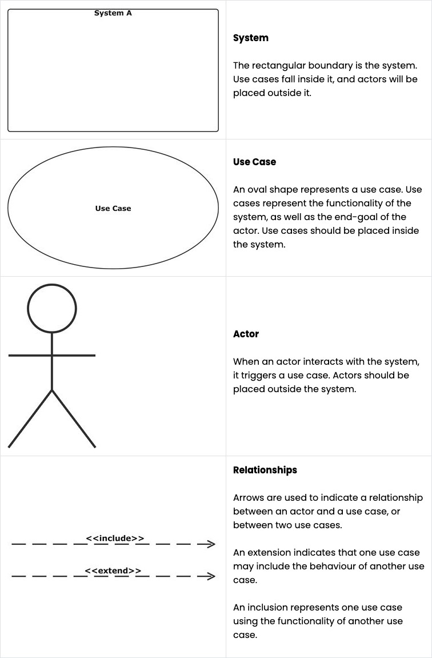

Use case diagram (Admin)

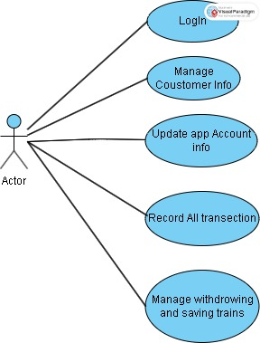

### Login:

* + Description: Represents the process of a user logging into the system.
  + Preconditions: The user must have valid credentials (username and password).
  + Postconditions: The user gains access to the system and their session is established.
  + Actors: Typically, the "User" actor is associated with this use case.
  + Basic Flow:

1. User enters valid username and password.
2. System validates the credentials.
3. If valid, the user is granted access to the system; otherwise, an error message is displayed.

### Dashboard View:

* + Description: Represents the main dashboard or landing page of the system.
  + Preconditions: The user must be logged in.
  + Actors: The "User" actor interacts with this use case.
  + Basic Flow:

1. After login, the user is directed to the dashboard, where they can access various features and functionalities of the system.

### Manage Categories:

* + Description: Allows users to create, edit, or delete categories (e.g., product categories or content categories).
  + Preconditions: The user must be logged in and have appropriate permissions.
  + Actors: This use case might involve roles like "Admin" or "Content Manager."
  + Basic Flow:

1. User selects the option to manage categories.
2. User can then perform actions such as creating, editing, or deleting categories.

### Manage Sliders:

* + Description: Enables users to manage content or images in the sliders of the system's user interface.
  + Preconditions: The user should be logged in and have the necessary permissions.
  + Actors: Users with roles like "Content Manager" or "Webmaster" may be associated.
  + Basic Flow:

1. User selects the option to manage sliders.
2. User can add, edit, or remove content in the sliders.

### Manage About-Us:

* + Description: Allows users to update and maintain the "About Us" section of the system, which typically contains information about the organization or website.
  + Preconditions: User login and appropriate permissions are required.
  + Actors: Roles like "Admin" or "Content Editor" may use this use case.
  + Basic Flow:

1. User selects the option to manage the "About Us" section.
2. User can edit and update the content.

### Manage Index:

* + Description: Represents the management of the system's homepage or index page content.
  + Preconditions: User authentication and permissions are needed.
  + Actors: Roles like "Admin" or "Content Editor" may use this use case.
  + Basic Flow:

1. User selects the option to manage the homepage.
2. User can edit and update the content displayed on the homepage.

### Manage Dining, Event, Gallery:

* + Description: These use cases likely represent the management of specific content sections related to dining, events, and galleries.
  + Preconditions: User authentication and relevant permissions are required.
  + Actors: Roles such as "Content Manager" or "Event Coordinator" may be associated with these use cases.
  + Basic Flow:

1. Users can perform actions related to the specific content section, such as adding, editing, or removing items or information.

### Logout:

* + Description: Represents the process of a user logging out of the system.
  + Preconditions: The user must be logged in.
  + Postconditions: The user's session is terminated, and they are logged out.
  + Actors: The "User" actor interacts with this use case.
  + Basic Flow:

1. User selects the logout option.
2. The system logs the user out, and they are redirected to the login page.

Use case diagram (User)

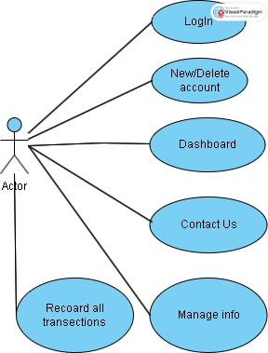

### Index Page:

* + Description: The homepage of the website or application, typically the first page users see when they visit.
  + Purpose: To provide an overview and quick access to important sections or content.
  + Content: Includes key highlights, announcements, or featured content.
  + Navigation: Typically includes links or buttons to other sections or pages.

### About Us:

* + Description: A section that provides information about the organization, company, or website.
  + Purpose: To communicate the mission, history, and values of the entity.
  + Content: Often includes details about the team, company history, and the organization's story.

### Services:

* + Description: A section showcasing services of the organization.
  + Purpose: To visually engage and inform users.
  + Content: Displays photos, videos, or multimedia presentations.

### Contact Us:

* + Description: A page or section where users can get in touch with the organization.
  + Purpose: To facilitate communication and inquiries.
  + Features: Contact forms, contact details, and possibly a map showing the location.

### Login:

* + Description: A feature allowing users to sign up for the Bank account.
  + Purpose: To acquire new members and offer exclusive benefits.
  + Features: Registration forms, login Forms.
    1. 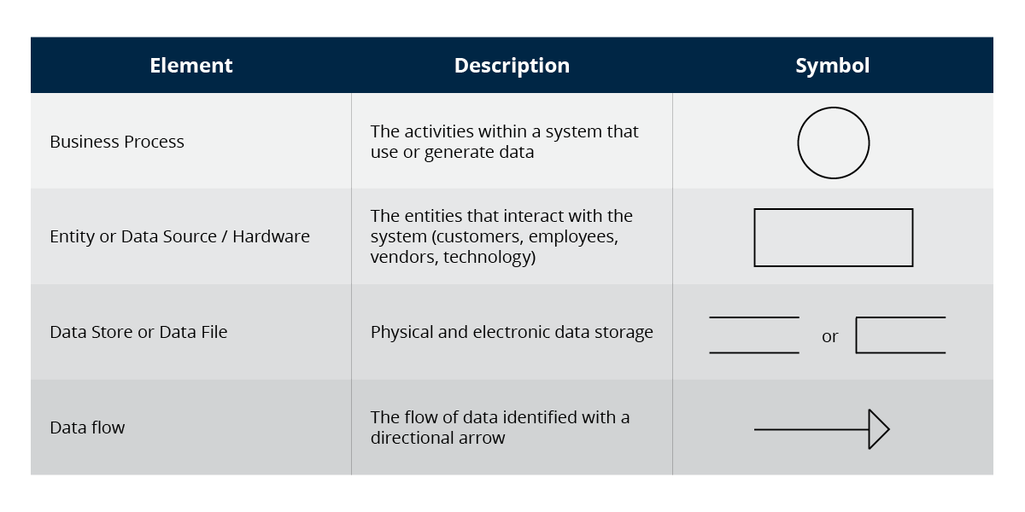Data flow diagram(DFD)

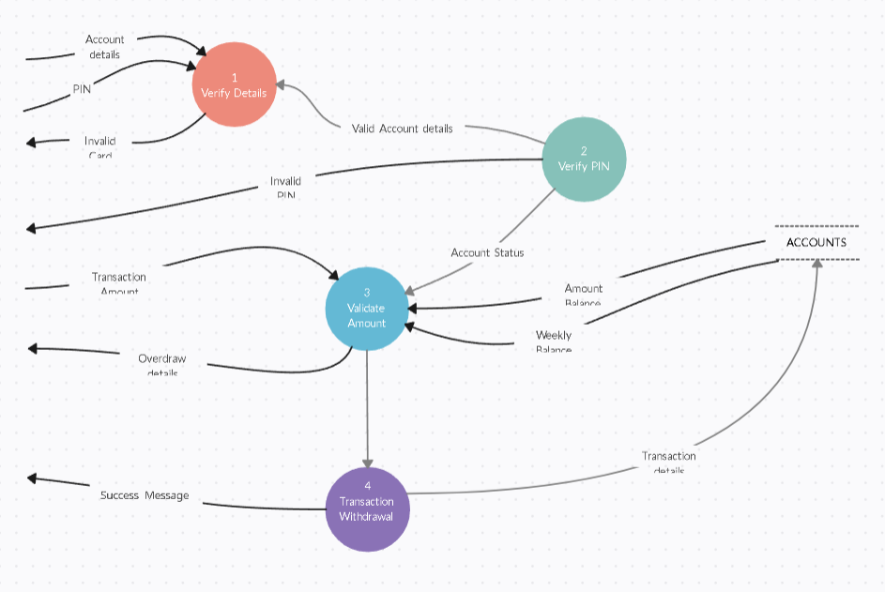

* + 1. **ER Diagram**

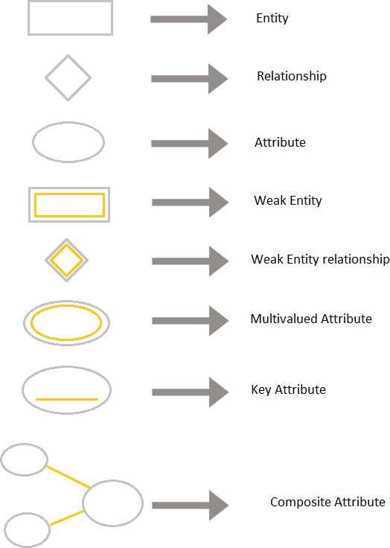

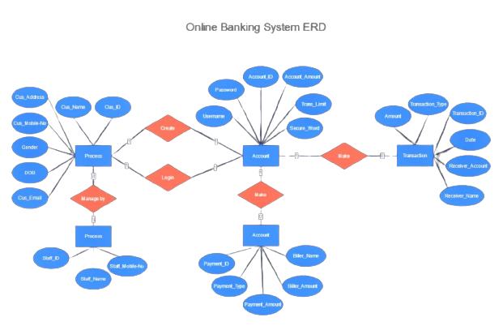

### Entities:

* + Entities are objects, concepts, or things that have data to be stored in a database. They are represented by rectangles in an ER diagram.
  + Each entity corresponds to a table in a relational database.

### Attributes:

* + Attributes are properties or characteristics of entities. They provide more details about the entity.
  + Attributes are typically represented within ovals connected to their respective entities.

### Primary Key:

* + The primary key is an attribute (or a combination of attributes) that uniquely identifies each record (tuple) within an entity.
  + It ensures that there are no duplicate records in the table.

### Relationships:

* + Relationships represent how entities are related to each other in the database.
  + Relationships are typically represented by diamond shapes connecting related entities.

### Cardinality:

* + Cardinality defines the number of instances of one entity that can be associated with another entity through a relationship.
  + Common cardinality notations include "1" (one), "0..1" (zero or one), "0..*" (zero or more), and "1..*" (one or more).

### Foreign Key:

* + A foreign key is an attribute within an entity that establishes a link to the primary key of another entity.
  + It creates a relationship between two tables in a relational database.

**4.1.4 Module Design**

Admin Side After Login

* + - * Dashboard
      * Customer Information
      * Feedback Information
      * Newsletter Information
      * Contact Information
      * Logout

User Side

Index

* About Us
* Services
* Contect Us
* Login

**4.1.5 Data Dictionary**

Database Structure:

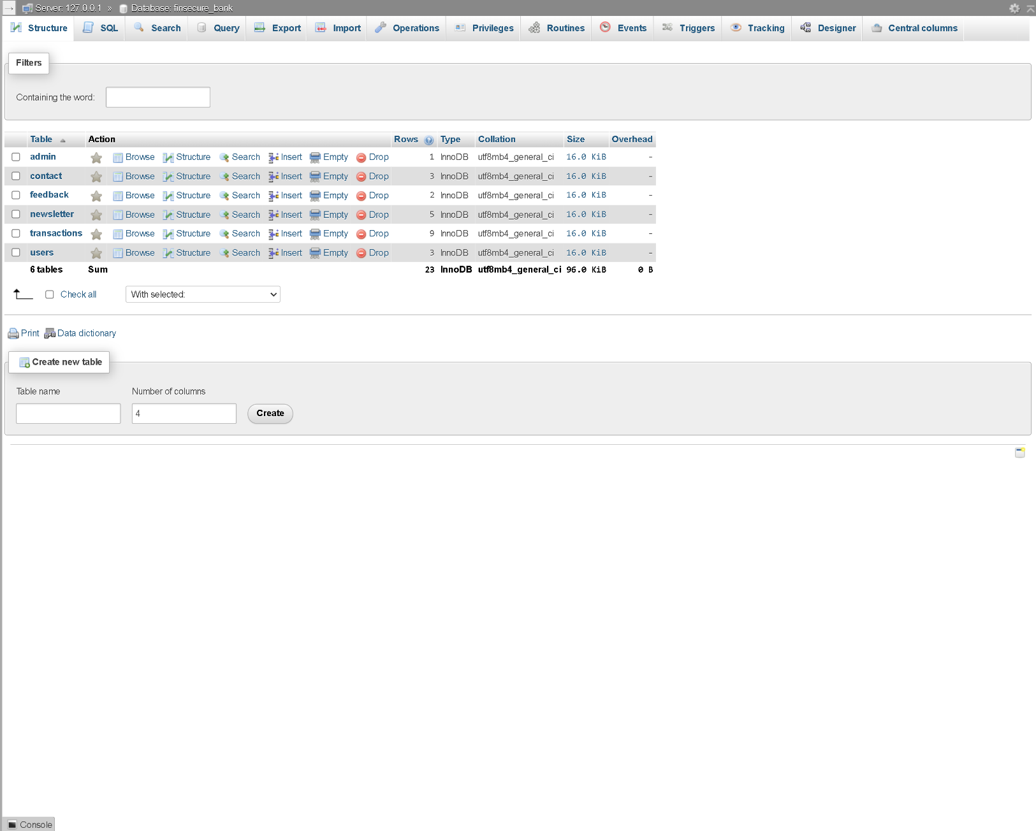

Table: Admin

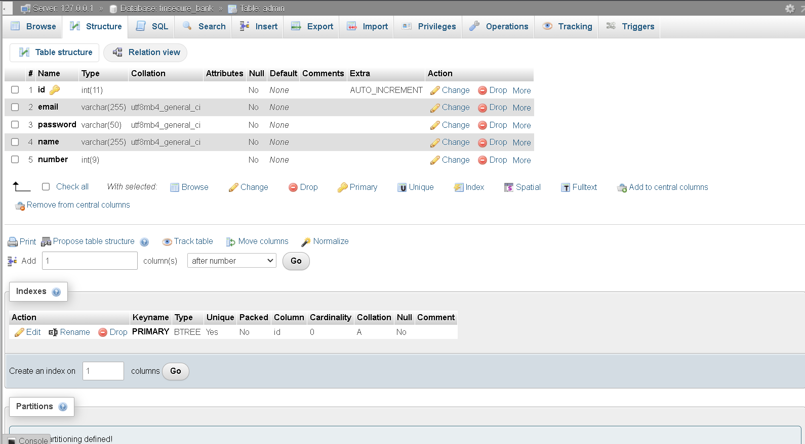

Table:Contact

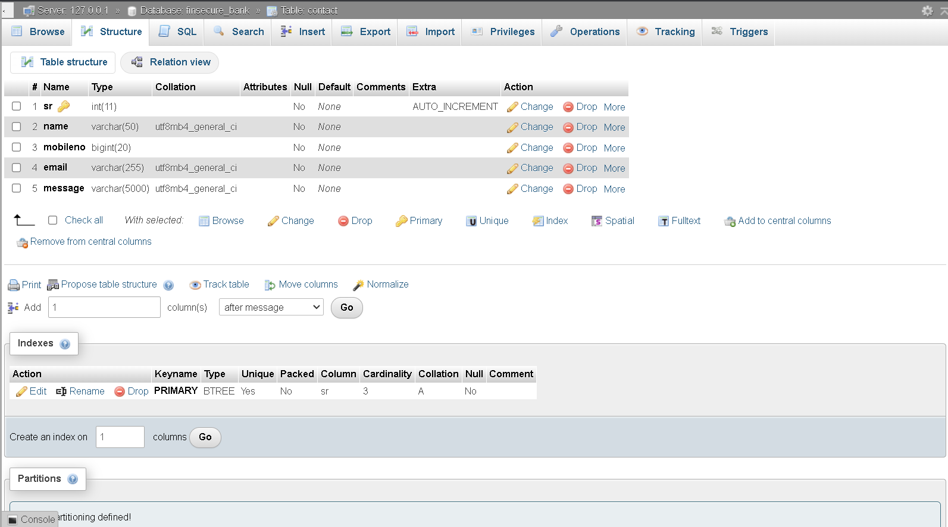

Table:Feedback

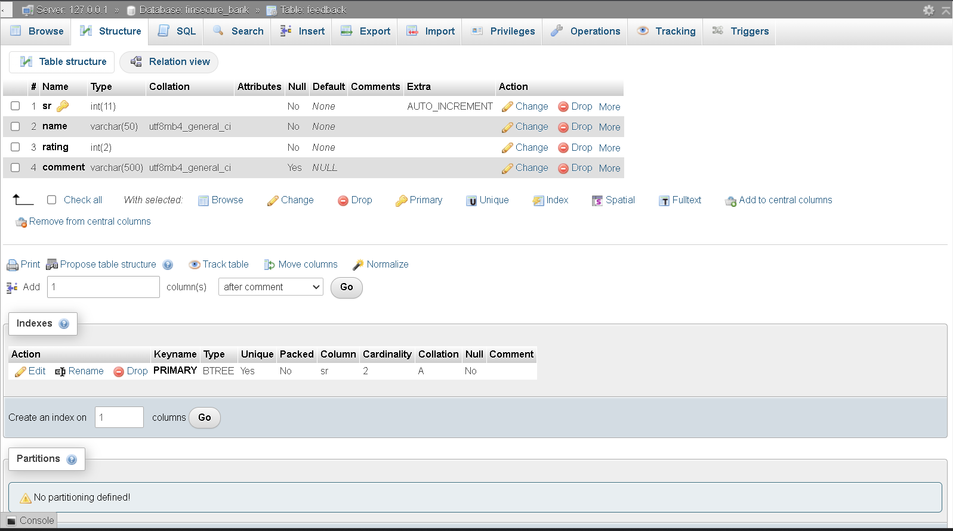

Table:Newsletter

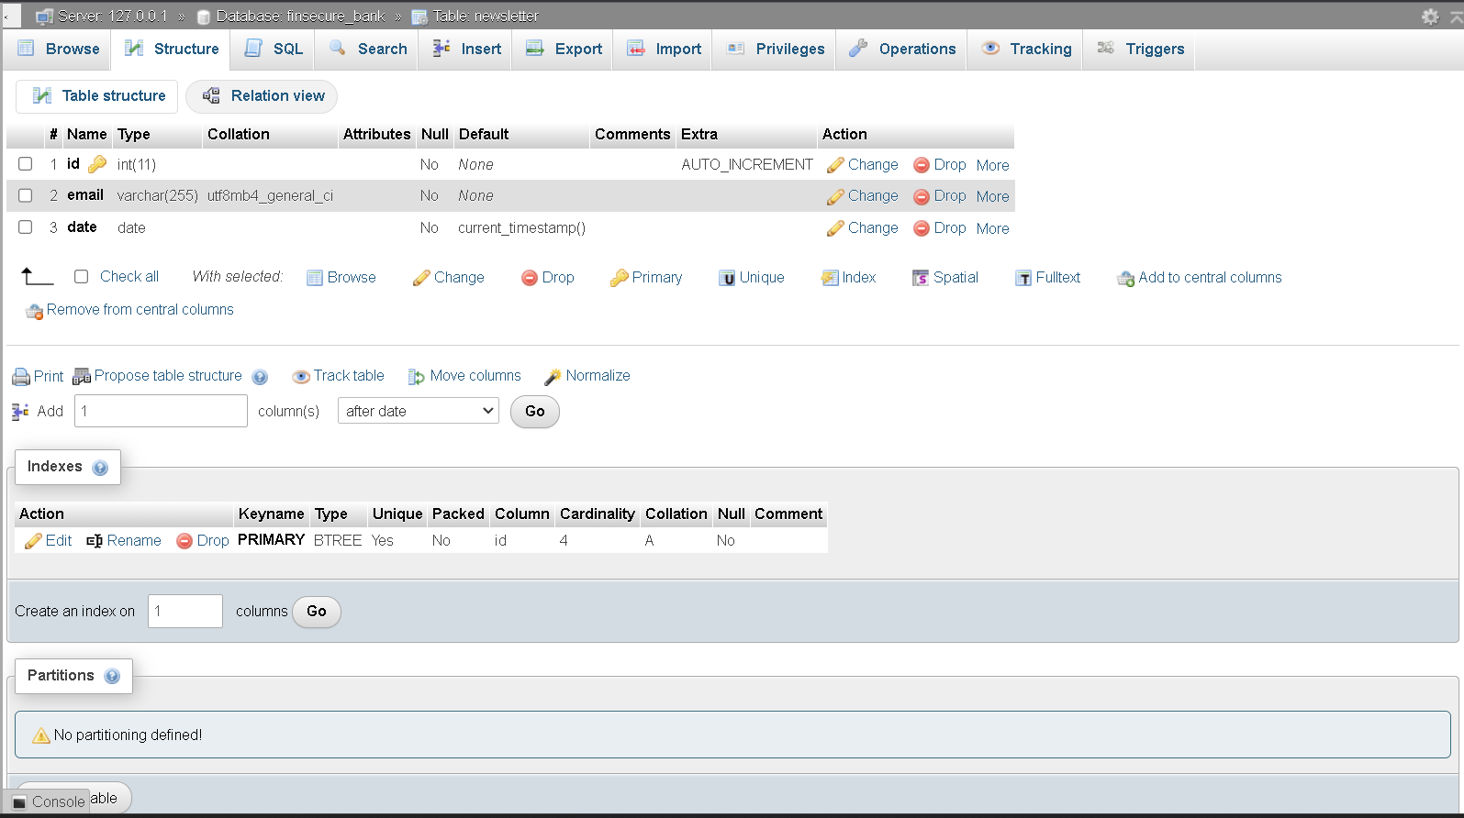

Table:Transection

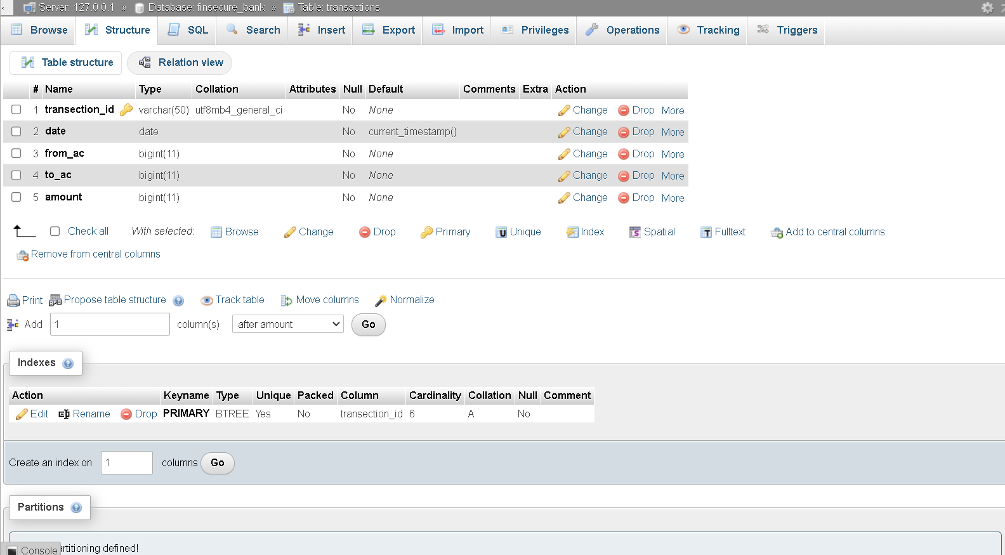

Table:Users

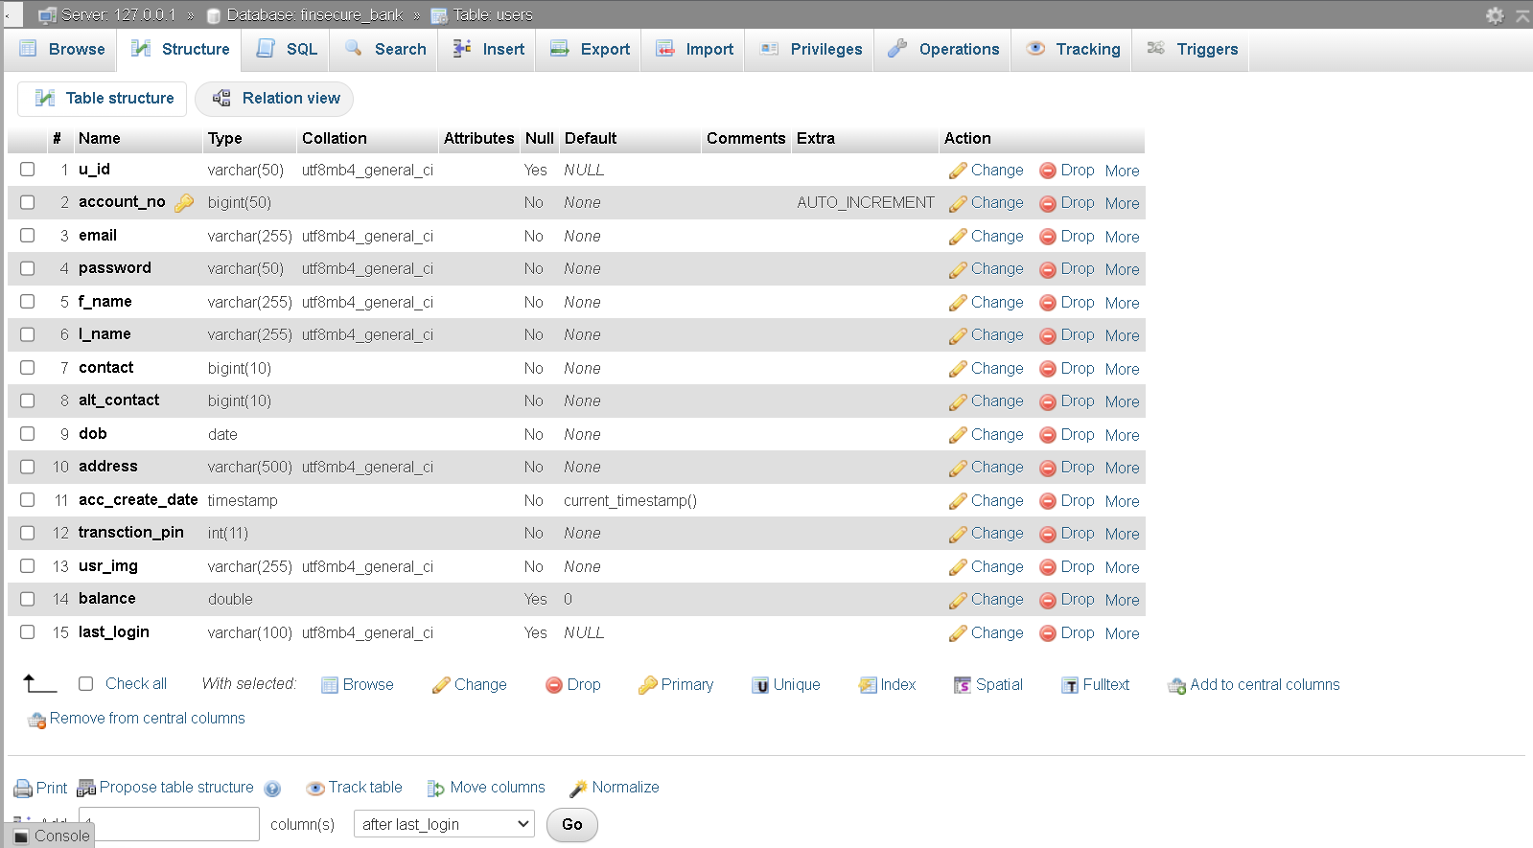

Chapter 5:

ScreenLayout And

Testing

**CHAPTER 5 :SCREENLAYOUT AND TESTING**

**5.1 Screen Layout**

**5.1.1** Admin Side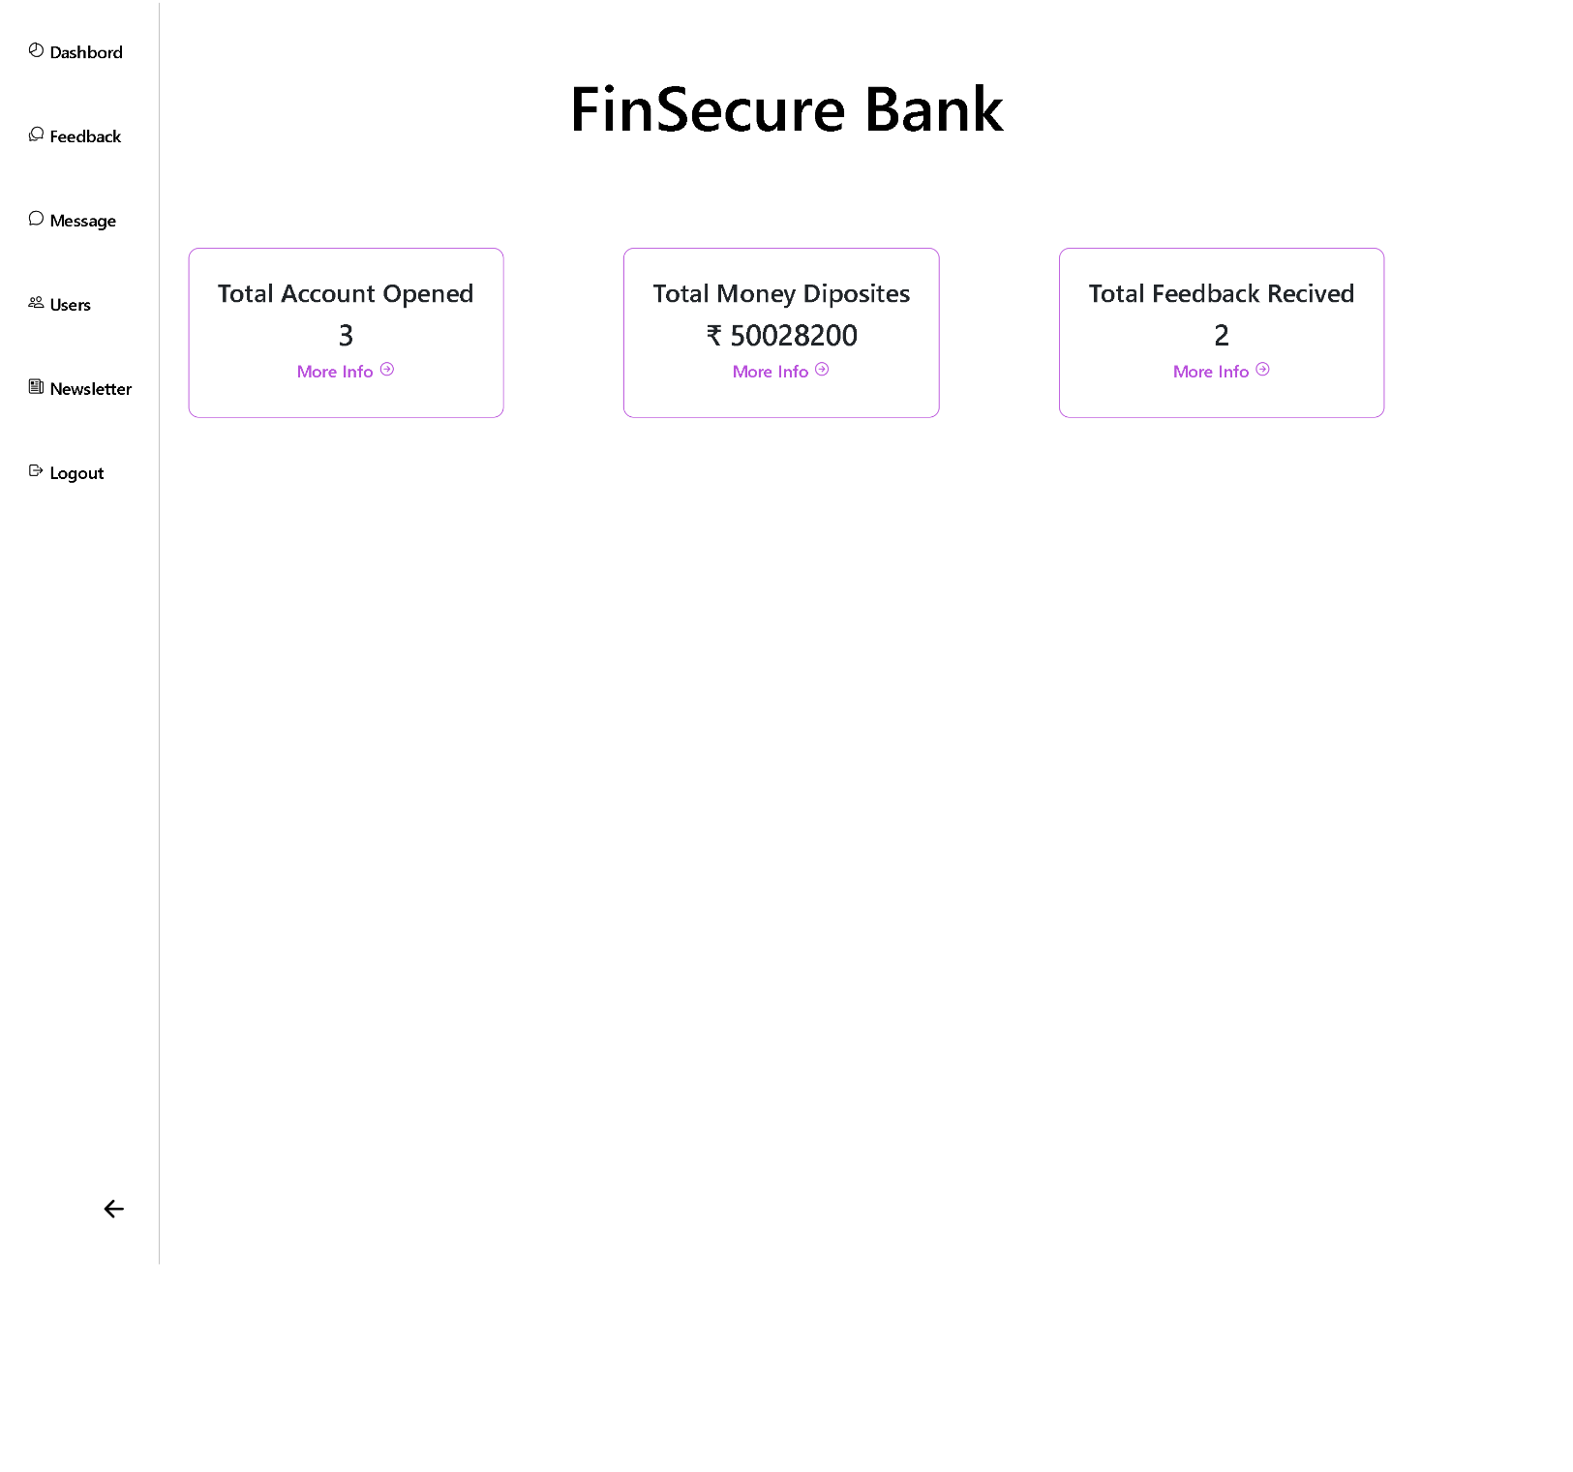

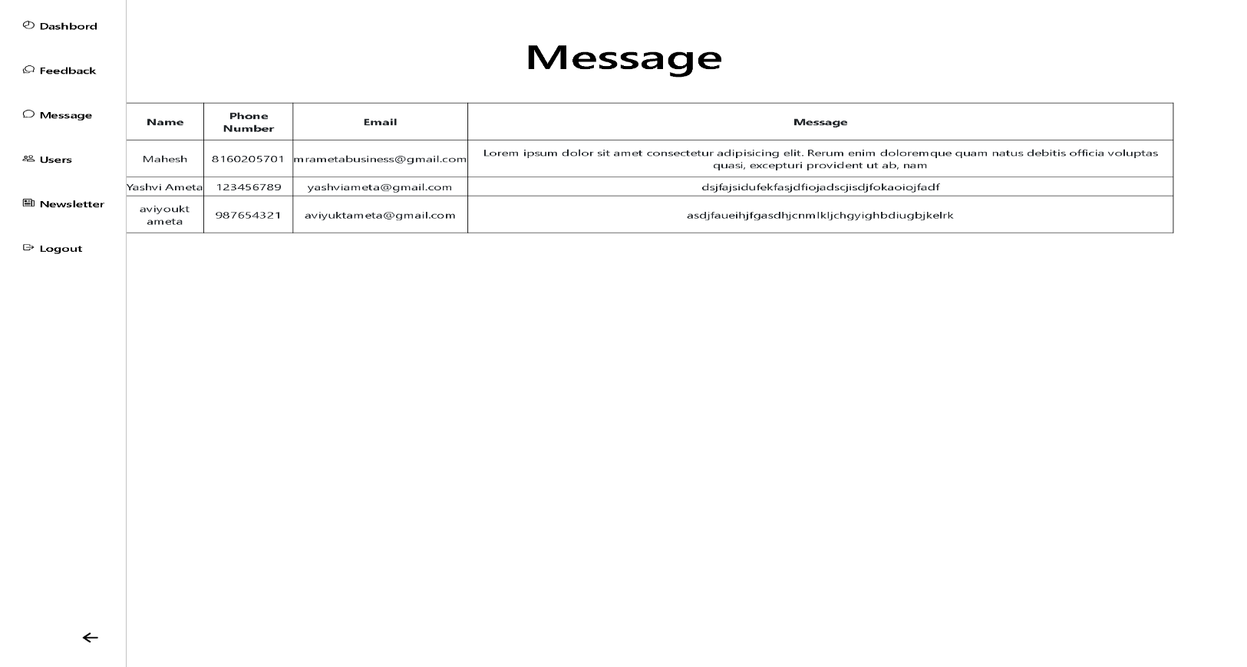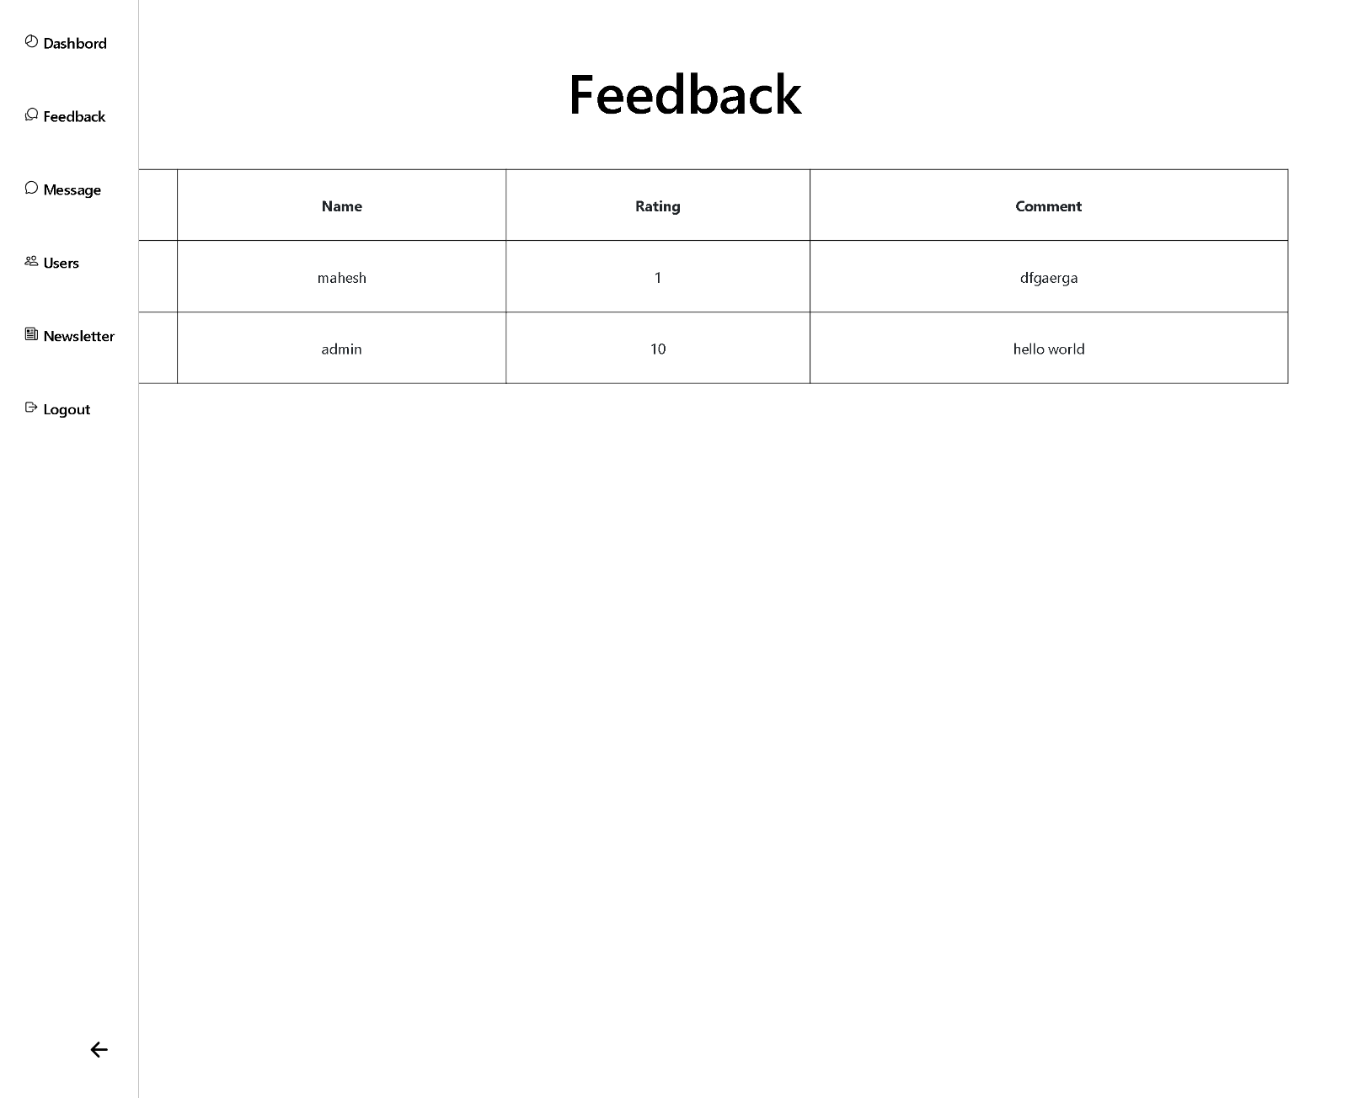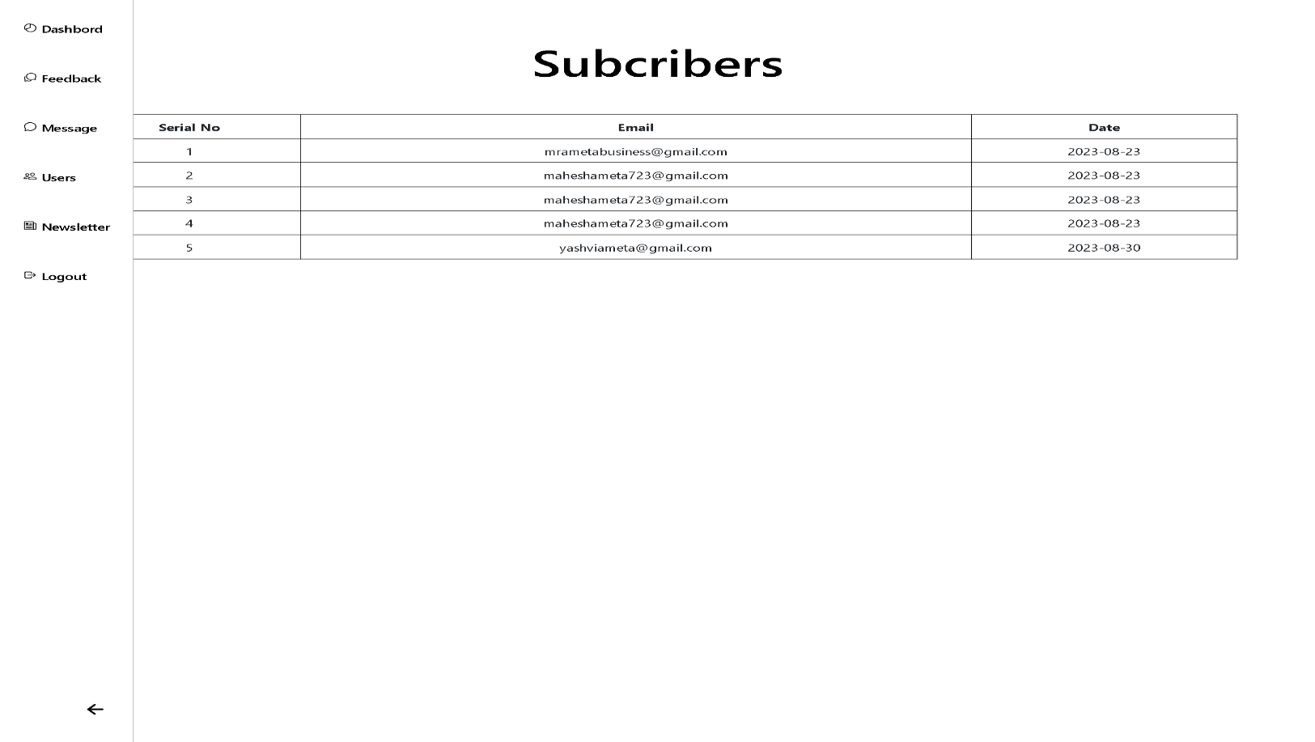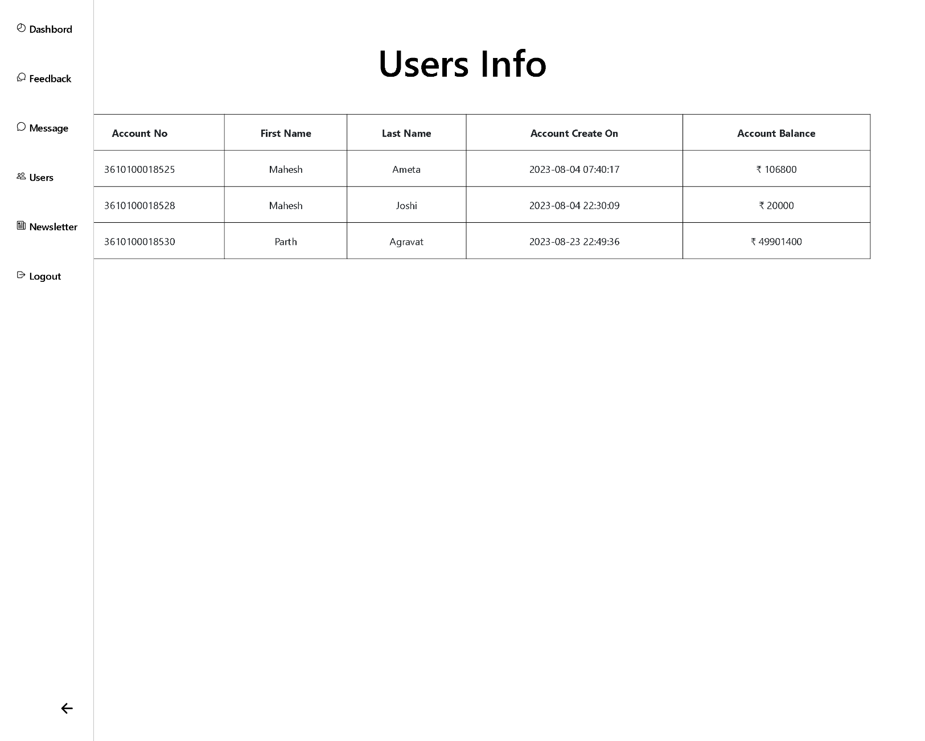

**User Side:**

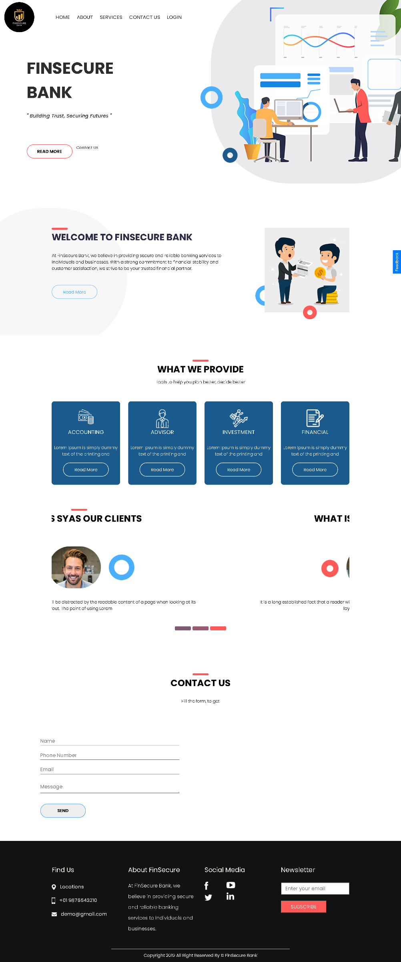

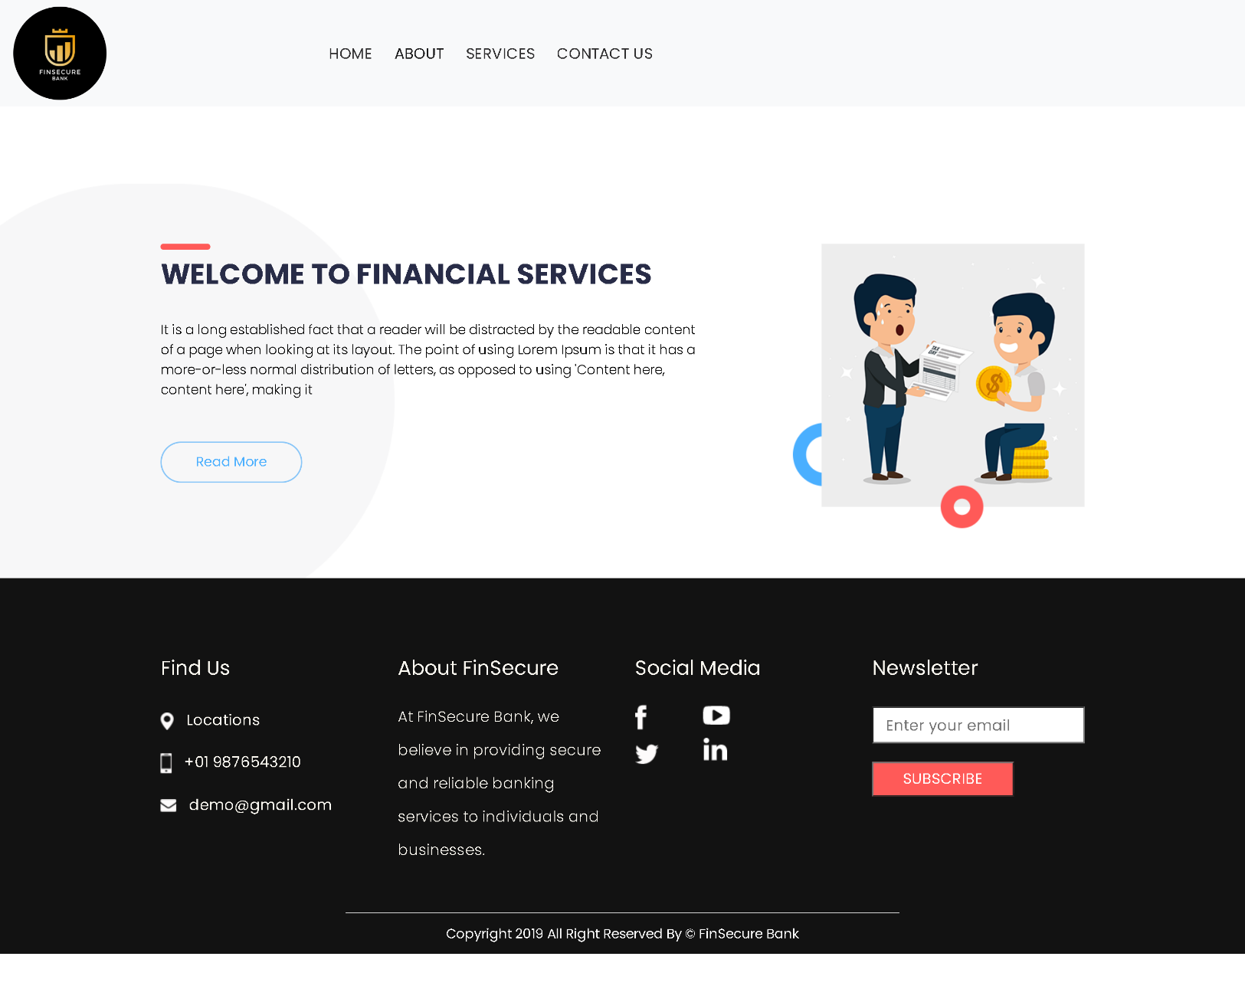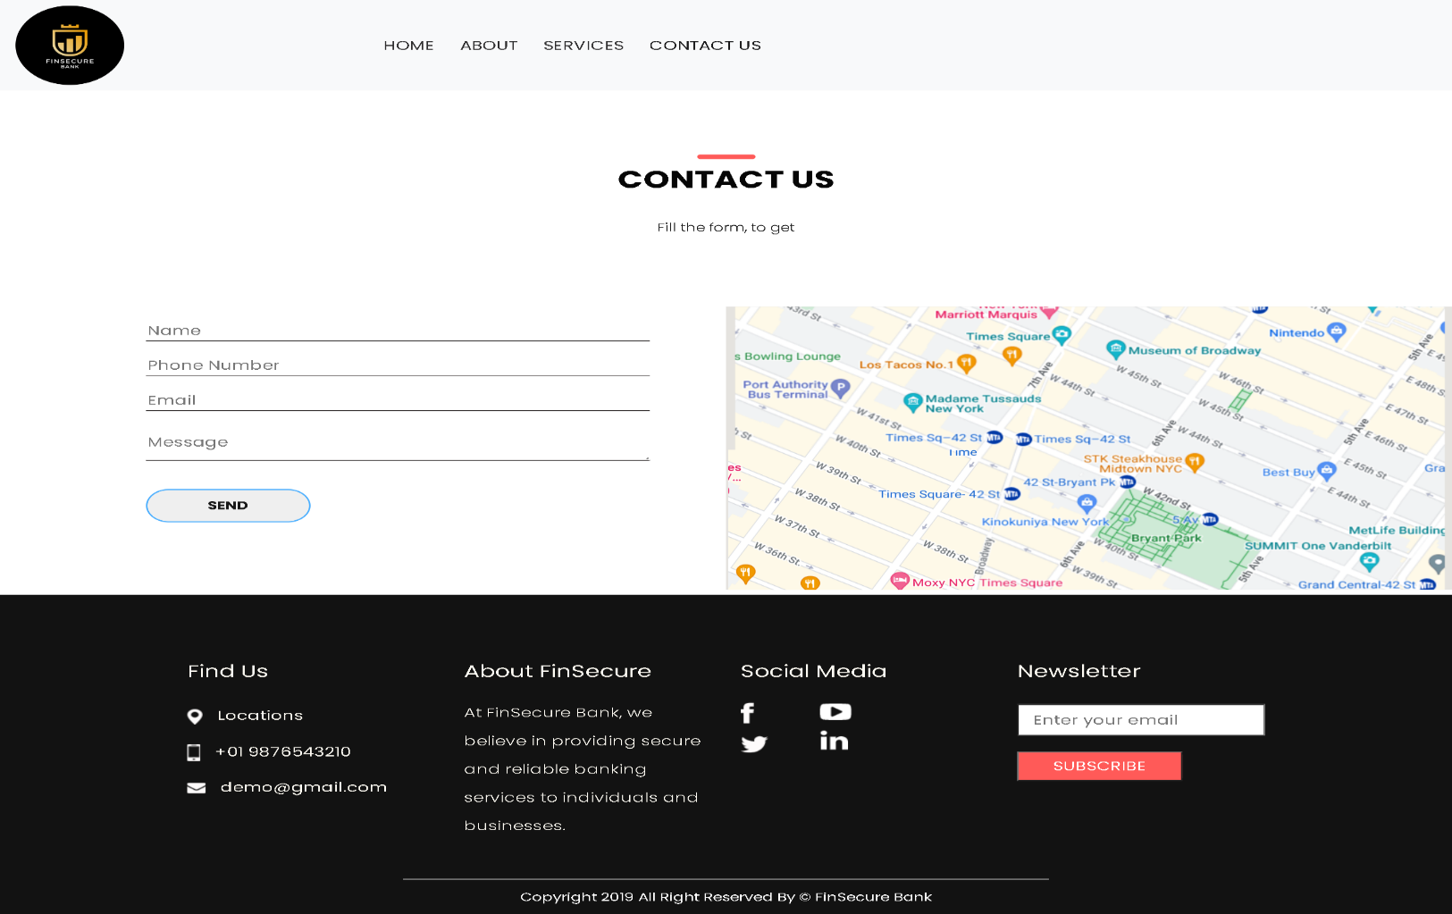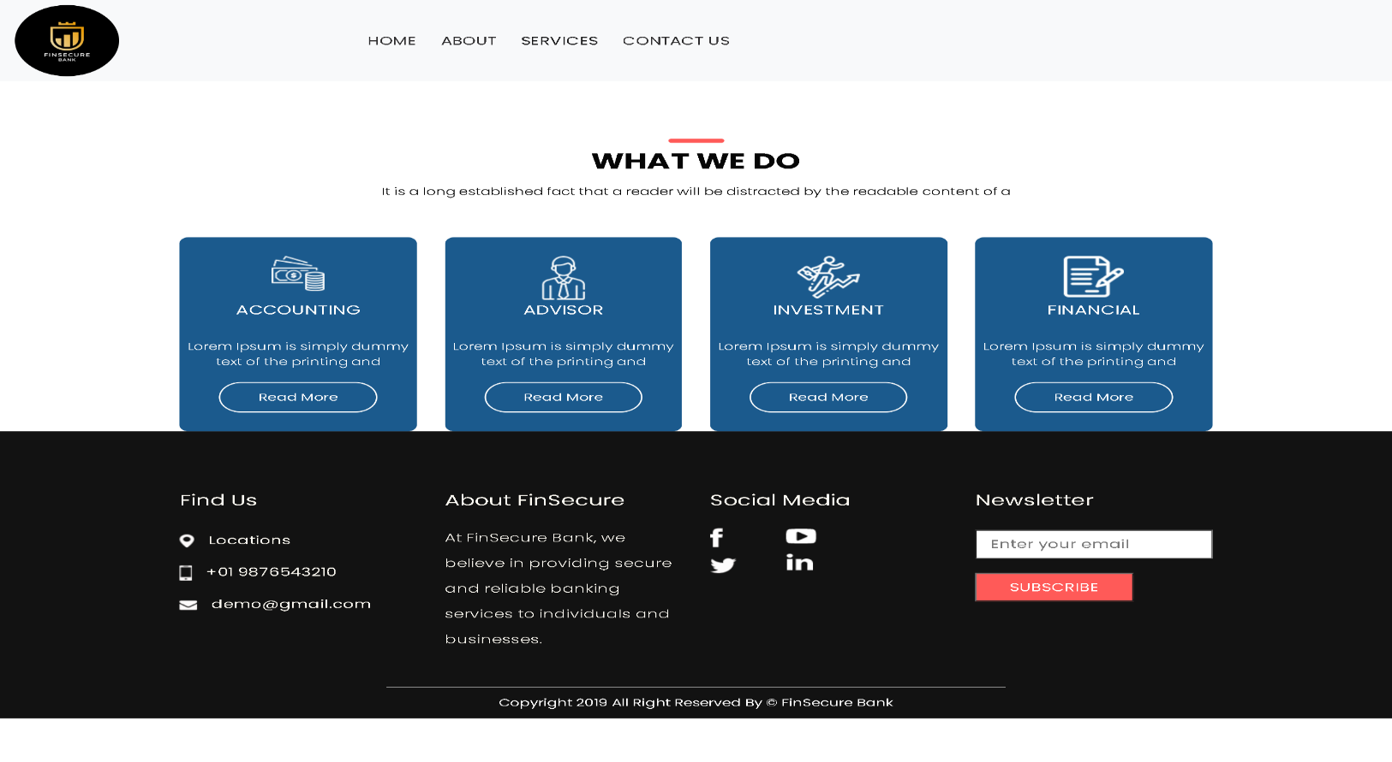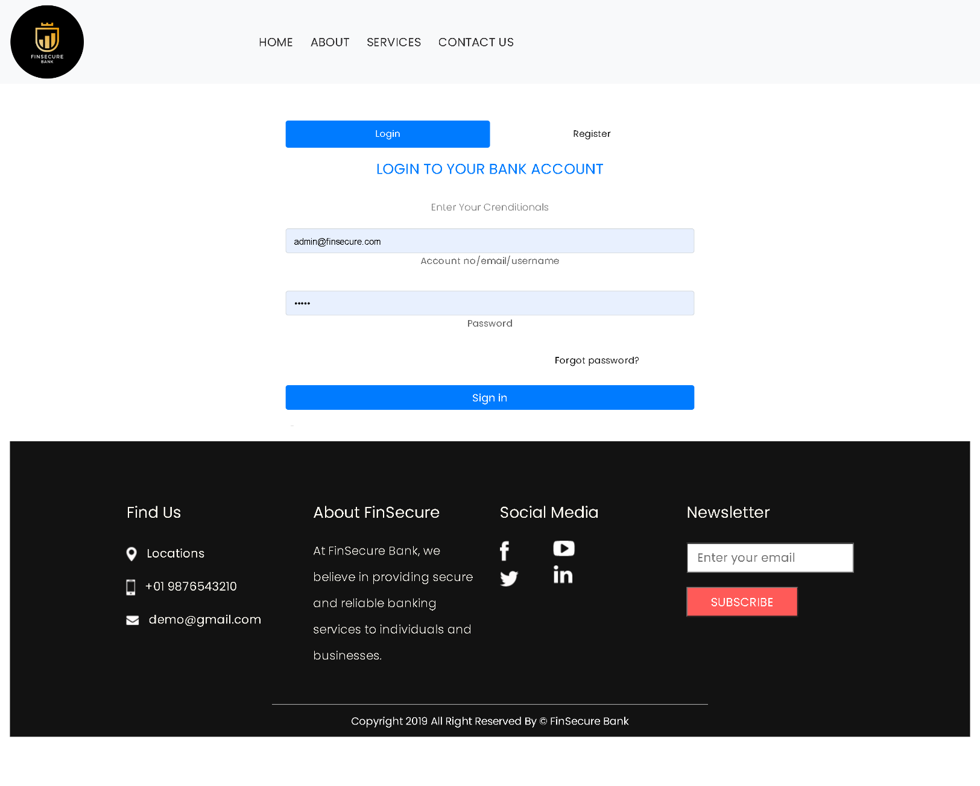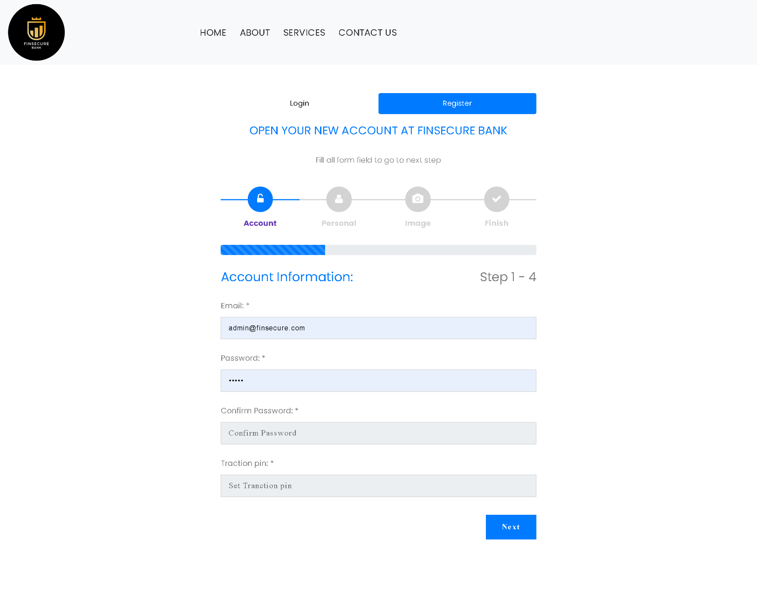

**5.2 Testing Approach**

**Performance Testing**:

* **Load Testing**: Evaluate the system's ability to handle a high volume of concurrent users and transactions, especially during peak times.
* **Stress Testing**: Test the system's performance under extreme conditions, such as sudden traffic spikes or resource-intensive operations.
* **Scalability Testing**: Assess the platform's scalability to ensure it can accommodate growth in users and data.
* **Response Time Testing**: Measure and optimize response times for critical functions and pages to provide a smooth user experience.

**Compatibility and Usability Testing**:

* **Cross-Browser Testing**: Test the platform on various web browsers (e.g., Chrome, Firefox, Safari, Edge) to ensure compatibility.
* **Mobile Responsiveness**: Verify that the platform is responsive and functional on different devices and screen sizes, including smartphones and tablets.
* **Usability Testing**: Involve real users to assess the user interface, navigation, and overall user experience. Gather feedback to make improvements.

Chapter 6:

System Security And

Measures

**CHAPTER 6 : SYSTEM SECURITY AND MEASURES**

**1. Data Encryption**:

* **SSL/TLS Encryption**: Implement SSL/TLS encryption for all data transmitted between users and your casino platform. This includes login credentials, financial transactions, and personal information.
* **Data at Rest Encryption**: Encrypt sensitive data stored in databases, ensuring that even if a breach occurs, the data remains protected.

**2. User Authentication and Authorization**:

* **Strong Password Policies**: Enforce strong password policies, including password complexity requirements and regular password changes.
* **Multi-Factor Authentication (MFA)**: Offer MFA as an option to enhance user account security, particularly for financial transactions.
* **Access Control**: Implement role-based access control (RBAC) to restrict user access to specific features and data based on their roles and responsibilities.

**3. Regulatory Compliance**:

* **Age Verification**: Implement robust age verification processes to ensure that users meet the legal gambling age requirements in their jurisdiction.
* **Geolocation Services**: Use geolocation services to verify that users are physically located in regions where online gambling is legal.
* **Compliance Audits**: Conduct regular compliance audits to ensure adherence to regional and international gambling laws and regulations.

**4. Responsible Gambling Features**:

* **Deposit Limits**: Allow users to set deposit limits to prevent excessive gambling.
* **Self-Exclusion**: Provide self-exclusion options for users who wish to temporarily or permanently suspend their accounts.
* **Time Limits**: Implement session time limits and reminders to encourage responsible gaming behavior.

Chapter 7:

Future Scope And

Enhancement

**CHAPTER 7 : FUTURE SCOPE AND ENHANCEMENT**

**Ongoing Improvement**

* **Continuous Testing**: Maintain a robust testing regimen to identify and address issues promptly. Regularly update and expand your test cases to cover new features and functionalities.
* **User Feedback**: Encourage user feedback and reviews to gather insights into areas that require improvement. Act on user suggestions and concerns to enhance the user experience.

**Technological Advancements**

* **New Technologies**: Stay updated with emerging technologies in the online gambling industry, such as virtual reality (VR), augmented reality (AR), and blockchain. Evaluate their potential for integration into your platform.

Chapter 8:

Conclusion And

Limitations

**CHAPTER 8 : CONCLUSION AND LIMITATIONS**

**Conclusion**

• **Project Objectives**: Reiterate the primary objectives and goals of our project.

• **Achievements**: Summarize the key accomplishments and milestones reached during the project's development and implementation.

• **User Benefits**: Highlight the benefits and value your casino platform offers to users, such as entertainment, convenience, and responsible gaming options.

**Compliance and Trust**: Emphasize your commitment to regulatory compliance, data security, and responsible gambling practices, building trust among users and stakeholders.

**Limitations**

* **Regulatory Constraints**: Describe any limitations or challenges related to regulatory compliance in different jurisdictions.
* **Technological Constraints**: Discuss any technology-related limitations, such as platform scalability or compatibility issues.
* **Resource Constraints**: Address resource limitations, including budget constraints, staffing challenges, or technology limitations.
* **Market Constraints**: Acknowledge challenges in entering specific markets or regions due to legal restrictions or market competition.
* **Security Risks**: Mention any security risks or vulnerabilities you encountered during development and how you mitigated them.
* **User Adoption**: Discuss any challenges in user adoption and strategies used to overcome them.

Chapter 9:

Biblography

**CHAPTER 9: BIBLOGRAPHY**

**Templets**

|  |
| --- |
| 1. <https://www.free-css.com/free-css-templates/page290/cryptop> |
| 1. <https://www.free-css.com/free-css-templates/page288/digitalex> |
| 1. <https://www.free-css.com/free-css-templates/page285/bitcypo> |
| 1. <https://www.free-css.com/free-css-templates/page255/currency-exchange> |
| 1. <http://free-css.com/free-css-templates/page259/digitco> |
| 1. <https://www.free-css.com/free-css-templates/page250/bell> |
| 1. <https://www.free-css.com/free-css-templates/page285/cial> |
| 1. <https://www.free-css.com/free-css-templates/page90/financia> |
| 1. <https://www.free-css.com/free-css-templates/page198/html-43> |
| 1. <https://www.free-css.com/free-css-templates/page169/vertex> |

**No. URL Of Existing Website/Software Features**

|  |  |  |
| --- | --- | --- |
| 1 | [**https://www.bankofbaroda.in/**](https://www.bankofbaroda.in/) | Deposit Accounts,Loans,ATM Services,Money Transfers |
| 2 | <https://sbi.co.in/> | Deposit Accounts,Loans,ATM Services,Money Transfers,Online and Mobile Banking,Financial Education |
| 3 | <https://bankofindia.co.in/> | Government Schemes,NRI Banking,Investment and Wealth Management,Internet and Mobile Banking,Retail and Corporate Banking |
| 4 | <https://www.unionbankofindia.co.in/> | Branch Network,Government Schemes and Initiatives,Banking Products and Services,Corporate Banking,International Banking |
| 5 | <https://indianbank.in/en/> | Public Sector Bank,Financial Products and Services,Branch Network,Priority Sector Lending,Corporate and Retail Banking |
| 6 | <https://www.rbi.org.in/> | Monetary Policy,Banker to the Government,Currency Issuance,Banking Regulation and Supervision,Developmental Functions |
| 7 | <https://www.centralbankofindia.co.in/en> | Banking Services,Digital Banking,ATM Services,Debit and Credit Cards,Government Schemes |
| 8 | <https://www.paypal.com/> | Online Payments,International Transactions,Security,Multiple Funding Sources,Mobile Payments,Peer-to-Peer Payments |
| 9 | <https://www.hdfcbank.com/> | Retail Banking,Credit Cards,Net Banking and Mobile Banking,Loans and Mortgages,Investment and Wealth Management |
| 10 | <https://www.axisbank.com/> | Retail and Corporate Banking,Internet and Mobile Banking,NRI Banking,Wealth Management,Priority Banking |